University at Buffalo Department of Orthopaedics
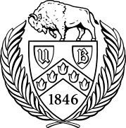

RESEARCH NEWSLETTER

Volume 6, June 2017

June A. and Eugene R. Mindell, MD Professor and Chair: Leslie J. Bisson, MD

Director of Clinical Research: John Leddy, MD

Director, Kenneth A Krackow Orthopedic Research Lab: Mark Ehrensberger, PhD

Editors: Melissa Kluczynski, MS; Sonja Pavlesen, MD, MS

Introduction

We’ve just finished another academic season, and our department has completed several noteworthy projects, as well as initiated others. Mark Ehrensberger continues to make significant contributions in the area of implant infections, John Leddy is becoming increasingly rec-ognized as a leader in concussion research, and John Marzo has lev-eraged an investigative relationship with Carestream into studies that are changing the way we understand ankle fractures and patellar in-stability. I’ve been a proud member of a team that completed a three-year level one trial that will change the way we treat chondral lesions encountered during meniscal surgery, and which will hopefully stimu-late similar intra-departmental projects. Our department’s investigative team has secured intra- and extra-mural funding from eleven separate sources, including foundations, industry, and the NIH. We had an ex-cellent set of resident projects presented at this year’s graduation, and articles authored by residents, fellows, and faculty have won awards. In short, it’s a very exciting time for investigations in our de-partment!

Please take a moment to thank the excellent support staff that makes all of this happen – Drs. Leddy, Ehrensberger, and Pavlesen, Melissa Kluczynski, Mary Bayers-Thering, Kathleen Lafferty, and Laura Ryan, as well as all the basic science personnel including Craig Howard, Menachem Tobias and Jenna Ferrentino – we couldn’t do any of this without them!

Leslie J. Bisson, MD

June A. and Eugene R. Mindell, MD, Professor and Chair

Department of Orthopaedics

Jacobs School of Medicine and Biomedical Sciences

University at Buffalo

Inside this issue
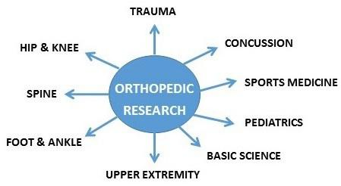

Introduction…………………….

Recently Funded Study………

Grant Deadlines.….…………..

Recent Publications………...

Recent Presentations………

Call for Abstracts……………...

Epidemiology Corner………....

Funded Research

Our department currently has 17 funded studies totaling over $3 million in research funding. Funders include the National Institutes of Health, University at Buffalo, Carestream Health, Inc., Ralph C. Wil-son Jr. Foundation, Stryker, OrthoSpace, Office of Naval Research, NYS Center of Excellence in Materials Informatics, Buffalo Institute for Genomics and Data Analytics, National Science Founda-tion, and Zimmer-Biomet. Congratulations to the following Principal Investigators and Co-Investigators: Drs. Leddy, Bisson, Marzo, Duquin, Ehrensberger, DiPaola, Phillips, and Rachala.

1

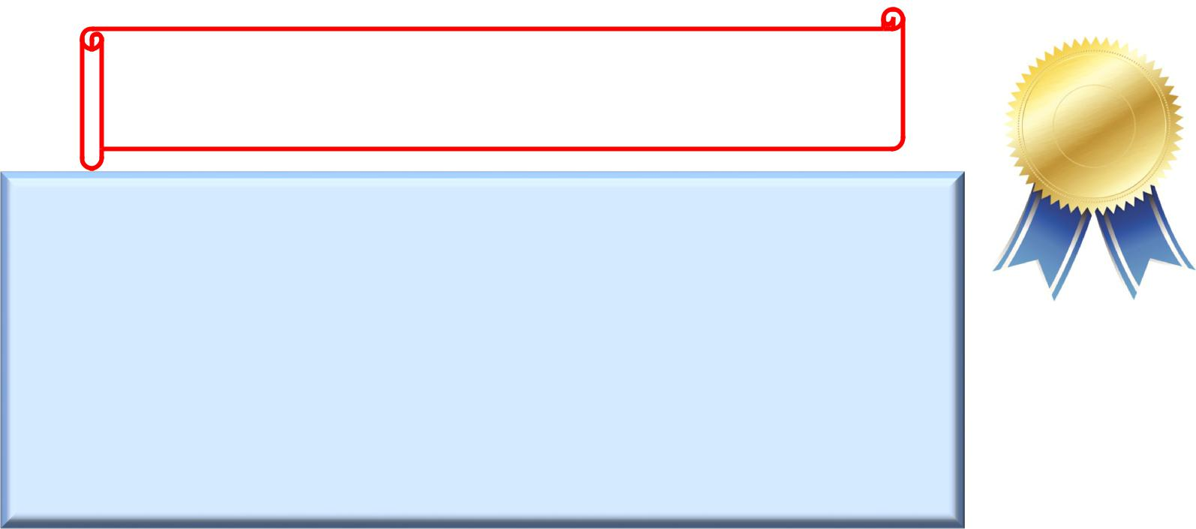
Congratulations to this year’s Orthopaedic Residency Program graduates: Allison Binkley, MD, Charles Gordon, MD, Tyler Kent, MD, Victor Marwin, MD, & Edward Schleyer, MD!

Congratulation to the 2017 Award Recipients

AAOS ASES 2017 Resident Research Award:
Boyle, K. manuscript: “Hemolysis Is a Diagnos c Adjuvant for Propionibacterium acnes Or-thopaedic Shoulder Infec on,” presented at the ASES Specialty Day mee ng March 18,2017 in San Diego, CA.

Recipient of the 2017 Douglas W. Brown Award for Best Review Paper:

Anderson, M., Browning, W., Urband, C., Kluczynski, M.A., Bisson, L.J. (2016). A systema c
summary of systema c reviews on the topic of the anterior cruciate ligament. Orthopaedic
Journal of Sports Medicine, 4(3): DOI: 10.1177/2325967116634074.

Recent Publications

Congratula ons to all authors!

Peer-Reviewed Ar cles:

Bisson, LJ, Kluczynski, MA, Wind, WM, Fineberg, MS, Bernas, GA, Rauh, MA, Marzo, JM, Zhou, Z, Zhao, Z. (in press). Pa ent-reported outcomes of debridement versus observa on of chondral lesions found during par al meniscectomy: The Chondral Lesions and Meniscus Procedures (ChAMP) Randomized Controlled Trial. Journal of Bone and Joint Surgery.

Boyle KK, Nodzo SR, Pavlesen S, Ri er CA. (in press). Tranexamic Acid Reduces Periopera ve Blood Loss and Hemarthrosis in Total Ankle Arthroplasty. American Journal of Orthopaedics.

Brooks EK, Ahn R, Tobias ME, Hansen LA, Luke-Marshall NR, Campagnari AA, Ehrensberger MT. (in press). Magnesi-um Alloy AZ91 Exhibits An microbial Proper es In Vitro But Not In Vivo. Journal of Biomedical Materials Research, Part B- Applied Biomaterials.

Brooks EK, Brooks RP, Ehrensberger MT. (2017). Eﬀects of Simulated Inflamma on on the Corrosion of 316L Stain-less Steel. Materials Science and Engineering: C, Materials for Biological Applica ons. 71: 200-205.

Browning, W, Kluczynski, MA, Curatolo, C, Marzo, JM. (in press). Suspensory versus aperture fixa on of

quadrupled hamstring tendon autogra in anterior cruciate ligament reconstruc on: a meta-analysis. American Journal of Sports Medicine.

Canty MK, Luke-Marshall NR, Campagnari AA, Ehrensberger MT. (2017). Cathodic voltage-controlled electrical s m-ula on of tanium for preven on of methicillin-resistant Staphylococcus aureus and Acinetobacter baumannii bio-film infec ons” Acta Biomaterialia, 48: 451-460.

Cappuccino A, Bisson L, Carpenter B, Snyder K, Cappuccino H. (in press). Systemic Hypothermia as Treatment for an Acute Cervical Spinal Cord Injury in a Professional Football Player: 9-Year Follow-Up. American Journal of Orthope-dics.

2

Recent Publications (continued)

Dorweiler MA, Van Dyke RO, Siska RC, Boin MA, DiPaola MJ. (2017). A Compara ve Biomechanical Analysis of 2 Double-Row, Distal Triceps Tendon Repairs. Orthopaedic Journal of Sports Medicine, (5) 5: 2325967117708308.

Echemendia RJ, Broglio SP, Davis GA, Guskiewicz KM, Hayden A, Leddy JJ Meehan WP, Putukian M, Sullivan J, Schneider KJ, and McCrory P. (in press). What tests and measures should be added to the SCAT3 and related tests to improve their reliability, sensi vity and/or specificity in sideline concussion diagnosis? A systema c review. Bri sh Journal of Sports Medicine.

Echemendia RJ, Davis GA, Putukian M, Leddy JJ, Makdissi M, Sullivan J,. Broglio SP, Ra eryferty M, Schneider KJ, Kissick J, Meeuwisse W, McCrory P, McCrea M, Dvorak J, Sills AK, Aubry M, Engebretsen L, Lossemore M, Fuller G, Kutcher J, Ellenbogen R, Guskiewicz KM, and Herring S. (in press). The Concussion Recogni on Tool 5th Edi on (CRT5). Bri sh Journal of Sports Medicine.

Echemendia RJ, Davis GA, Putukian M, Leddy JJ, Makdissi M, Sullivan J,. Broglio SP, Ra eryferty M, Schneider KJ, Kissick J, Meeuwisse W, McCrory P, McCrea M, Dvorak J, Sills AK, Aubry M, Engebretsen L, Lossemore M, Fuller G, Kutcher J, Ellenbogen R, Guskiewicz KM, and Herring S. (in press). The Sport Concussion Assessment Tool 5th Edi on (SCAT)5. Bri sh Journal of Sports Medicine.

Haider MN, Leddy J, Baker JG, Pavlesen S, Kluczynski M, and Willer B. (in press). Measures of Recovery from Sport-Related Concussion in the Student Athlete: a Systema c Review. Bri sh Journal of Sports Medicine.

Haider MN, Leddy J, Baker JG, Kiel JM, Tiso M, Ziermann KA, and Willer B. (in press). Eﬀect of Specialized Concussion Management Training among Residents and Medical Students. Concussion.

Kamins J, Bigler ED, Covassin T, Henry L, Kemp S, Leddy JJ, Mayer, A, McCrea M, Prins M, Schneider K, Valovich McLeod T, Zemek R, and Giza CC. (in press). What is the Physiological Time to Recovery A er Concussion? Bri sh Journal of Sports Medicine.

Leddy J, Baker JG, Haider N, Hinds A, and Willer B. (2017). A Physiological Approach to Prolonged Recovery from Sport-related Concussion. Journal of Athle c Training, 52 (3): 299-308.

Leddy J, Hinds AL, Miecznikowski J, Darling S, Matuszak J, Baker JG, Picano J, and Willer B. (in press). Safety and Prognos c U lity of Provoca ve Exercise Tes ng in Acutely Concussed Adolescents: A Randomized Trial. Clinical Journal of Sports Medicine.

Makdissi M, Schneider J, Feddermann-Demont N, Guskiewicz K, Hinds S, Leddy JJ, McCrae M, Turner M,

and Johnston K. (in press). Approach to inves ga on and treatment of persistent symptoms following
sport-related concussion: A systema c review. Bri sh Journal of Sports Medicine.

Makki AY, Leddy J, Takano K, and Jain R. (in press). An Unusual Cause of Headache and Fa gue in a Division 1 Collegiate Athlete. Clinical Journal of Sports Medicine.

Mar n EJ, Duquin TR, Ehrensberger MT. (in press). Reverse total shoulder glenoid baseplate stability with superior glenoid bone loss. Journal of Shoulder and Elbow Surgery.

Marzo, J. Comparison of a novel weight bearing cone beam computed tomography (CT) scanner versus a conven onal CT scanner. (2017). Physical Medicine and Rehabilita on Research, 1(5): 1-3.

3

Recent Publications (continued)

McCrory P, Meeuwisse W, Dvorak J, Bailes J, Broglio S, Cantu RC, Cassidy D, Echemendia RJ, Castellani RJ,

Davis GA, Ellenbogen R, Emery C, Engebretsen L, Feddermann-Demont N, Giza CC, Guskiewicz KM, Herring S, Iverson GI, Johnston KM, Kissick J, Kutcher J, Leddy JJ, Maddocks D, Makdissi M, Manley G, McCrea M, Meehan WP, Nagahiro S, Patricios J, Putukian M, Schneider KJ, Sills A, Tator CH, Turner M, and Vos PE. (in press). Consensus statement on concussion in sport—the 5th interna onal conference on concussion in sport held in Berlin, October 2016. Bri sh Journal of Sports Medicine.

Nodzo SR, Boyle KK, Bhimani S, Duquin TR, Miller AO, Westrich GH. (in press). Propionibacterium acnes Host Inflammatory Response During Periprosthe c Infec on is Joint Specific. Hospital for Special Surgery Journal.

Nodzo SR, Boyle KK, Nocon AA, Henry MW, Mayman DJ, Westrich GH. (in press). The Influence of a

Failed Irriga on and Debridement on the Outcomes of a Subsequent Two-Stage Revision Knee
Arthroplasty. The Journal of Arthroplasty.

Nodzo, SR, Boyle KK, Nocon AA, Miller A, Westrich GH. (in press). Success Rates, Characteris cs, and Costs of Ar cula ng An bio c Spacers for Total Knee Periprosthe c Joint Infec on. The Knee.

Schneider KJ, Leddy JJ, Guskiewicz KM, Seifert TD, McCrea M, Silverberg ND, Feddermann-Demont N, Iverson GK, Hayden A, and Makdissi M. (in press). Rest and Specific Treatments Following Sport-Related Concussion: A Systema c Review. Bri sh Journal of Sports Medicine.

Published Abstracts:

Brownell B, Hinds AL, Willer B, Anderson N, Macfarlane A, Constan no D, and Leddy JJ. Comparison of the Buﬀalo Concussion Treadmill Test (BCTT) and the Buﬀalo Concussion Bike Test (BCBT) for the
Evalua on of Exercise Tolerance. Clin J Sports Med 27(2), 2017.

Recent Presentations

Posters:

Boyle KK, Nodzo SR, Ferraro J, Augenblick DJ, Pavlesen S, Phillips MJ. Uncemented vs Cemented Cruciate Retaining Total Knee Arthroplasty in Pa ents with a Body Mass Index Over 30. Orthopaedic Research Society. San Diego, CA. March 2017.

Boyle KK, Nodzo SR, Nocon AA, Miler AO, Westrich GW. Total Knee An bio c Spacer Outcomes for Periprosthe c Joint Infec on. Orthopaedic Research Society. San Diego, CA. March 2017.

Brooks EK, Canty MK, Ahn R, Tobias ME, Howard CS, Hansen LA, Luke-Marshall NR, Campagnari AA,

Ehrensberger MT. Risk of Magnesium Implant Infec ons: Mg2Sr Suppor ng MRSA Growth. Orthopedic Research Society. San Diego, CA. March 2017.

Canty MK, Luke-Marshall NR, Campagnari AA, Ehrensberger MT. “Preven on of Titanium Associated Acinetobacter baumannii Infec ons with Cathodic Electrical S mula on” Orthopedic Research Society. San Diego, CA. March 2017.

Dave R, Rachala S, Pavlesen S, Wang J, Touban B. Synovial Aspira on Cell Counts in Short Term Postopera ve Primary Total Knee Arthroplasty. Orthopaedic Research Society. San Diego, CA. March 2017.

4

Recent Presentations (continued)

Doak, J, Marwin, V. Non-Opera ve Management of Pediatric Grade I Open Fractures. European Pediatric Orthopaedic Society and Pediatric Orthopaedic Society of North America Combined Mee ng (EPOSNA) 2017. Barcelona, Spain.

Mar n EJ, Duquin TD, Ehrensberger MT. Measurement of Reverse Total Shoulder Glenoid Baseplate Stability with Superior Glenoid Bone Loss. Orthopedic Research Society. San Diego, CA. March 2017.

Nodzo SR, Boyle KK, Spiro S, Nocon AA, Henry M, Westrich GW. The Influence of Irriga on and Debridement On Two-Stage Revision in Total Knee Arthroplasty. American Academy of Orthopedic Surgeons. San Diego, CA. March 2017.

Puma KA, Phillips P, Ehrensberger MT. Mechanical Profile of Intramedullary Reaming in the Tibia. Orthopedic Re-

search Society. San Diego, CA. March 2017.

Schleyer E, Rohrbacher B, Spiracino G, Pavlesen S. Eﬀect of Pad Posi oning on Medial Clear Space Widening in Ankle Gravity Stress Views. Orthopaedic Research Society. San Diego, CA. March 2017.

Paper/Podium Presenta ons:

Boyle KK, Nodzo S, Wright TE, Crane JK, Duquin TR. (2017) Hemolysis is a diagnos c adjuvant for Propionibacterium acnes orthopaedic shoulder infec on. Podium presenta on at the American Shoulder and Elbow Surgeons 2017 Open Mee ng. San Diego, CA.

Boyle KK, Nodzo S, Wright TE, Crane JK, Duquin TR. (2017) Hemolysis is a diagnos c adjuvant for Propionibacterium acnes orthopaedic shoulder infec on. Podium presenta on at the American Academy of Orthopaedic Surgeons 2017 Annual Mee ng. San Diego, CA.

Brownell B, Hinds AL, Willer B, Anderson N, Macfarlane A, Constan no D, and Leddy JJ. Comparison of the Buﬀalo Concussion Treadmill Test (BCTT) and the Buﬀalo Concussion Bike Test (BCBT) for the Evalua on of Exercise Tolerance. American Medical Society for Sports Medicine. Annual Mee ng. May 2017. San Diego, CA.

Duquin TR. (2017) Treatment of Glenoid Bone Loss in Shoulder Arthroplasty. Instruc onal Course Lecture: When You’re Running Out of Room. American Academy of Orthopaedic Surgeons 2017 Annual Mee ng. San Diego, CA.

Ehrensberger MT, Canty MK, Luke-Marshall NR, Campagnari AA. Cathodic Voltage Controlled Electrical

- mula on for Preven on of Titanium Implant Associated Infec ons. Seventh Interna onal Conference Advances in Orthopaedic Osseointegra on. Coronado, CA. March 2017.

Hinds A, Leddy J, et al. Comparison of the Buﬀalo Concussion Treadmill Test and the Buﬀalo Concussion Bike Test for the Evalua on of Exercise Intolerance. Interna onal Brain Injury Associa on Mee ng. New Orleans, LA. March 2017.

5

Recent Presentations (continued)

Kluczynski, M., Bisson, L.J., Wind, W., Fineberg, M.S., Bernas, G.A., Rauh, M.A., Marzo, J.M., Zhao, J. Pa ent-reported Outcomes of Debridement vs. Observa on of Chondral Lesions Found

During Par al Meniscectomy. Paper presented at the American Academy of Orthopaedic Surgeons annual mee ng. San Diego, CA. March 2017.

Schoch BS, Aibinder WS, Walters J, Sperling JW, Throckmorton T, Sanchez-Sotelo J, Duquin TR. (2017) Are Outcomes of Uncemented Reverse Shoulder Arthroplasty for Acute Proximal Humerus Fractures Equivalent to Cemented Stems? Podium presenta on American Shoulder and Elbow Surgeons Open Mee ng. San Diego, CA

Invited Talks:

Ehrensberger, M. Electrical S mula on for Implant-Associated Infec on Control. Infec ous Disease Research Semi-
nar. Department of Medicine, University at Buﬀalo. Buﬀalo, NY. February 2017.

Leddy JJ. The Buﬀalo Concussion Treadmill Test (BCTT): Diﬀeren al Diagnosis and Exercise Treatment for Concussion and Post-Concussion Disorders. Webinar for “Concussion Health” Pre-summit. January 2017.

Leddy JJ. Ac ve Rehabilita on of Concussion and Post-Concussion Syndrome. 4th Annual Concussion in Sport: CONCUSSION ACROSS THE SPECTRUM OF INJURY. NYU-Langone Medical Center. New York, NY. February 2017.

Leddy JJ. Exercise as Interven on. Fourth Ma hew Gfeller Neurotrauma Symposium. University of

North Carolina. Chapel Hill, NC. March 2017.

Leddy JJ. Exercise in the role of the diagnosis and recovery from concussion. University of Michigan Neurology Grand Rounds. Ann Arbor, MI. March 2017.

Leddy JJ. Evidence Based Assessment and Treatment of Concussion. Interna onal Brain Injury Associa on Mee ng. New Orleans, LA. March 2017.

Leddy JJ. Case Presenta on- Sport Concussion. Interna onal Brain Injury Associa on Mee ng. New Orleans, LA. March 2017.

Leddy JJ. The Physiology of Concussion and the Female Athlete- PINK Concussion Symposium.

Interna onal Brain Injury Associa on Mee ng. New Orleans, LA. March 2017.

Leddy JJ. Physiological Recovery. Head Injury in Soccer: from science to the field. Major League Soccer.

New York, NY. April 2017.

Leddy JJ. Therapeu c Prac cal Procedures. Head Injury in Soccer: from science to the field. Major League Soccer. New York, NY. April 2017.

Marzo, J. Orthopedic Applica ons of a new CT Technology. SUNY University at Buﬀalo

Department of Orthopedic Surgery Ralph and Mary Wilson Visi ng Professor. Buﬀalo, NY. March 2017.

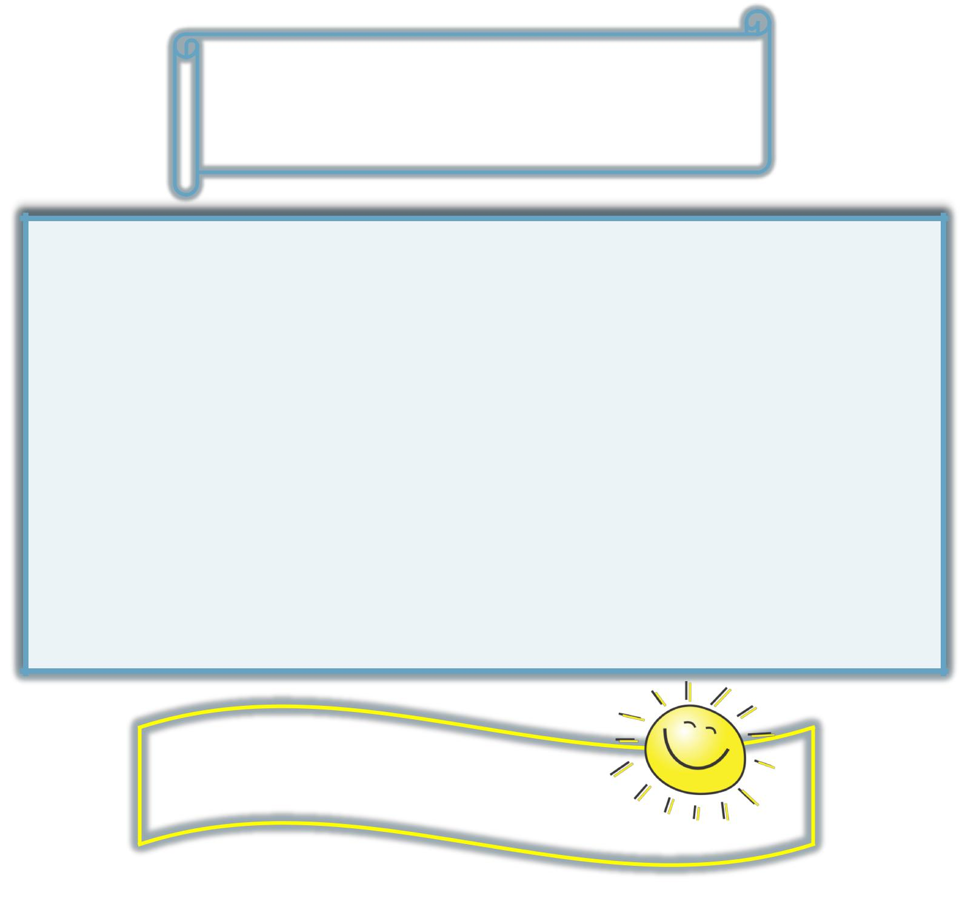
Call for Abstracts

ORS March 2018:

Opening Online Abstract Submission 06/26/2017

Close of Online Abstract Submission 08/28/2017

Epidemiology Corner: Sta s cal vs. Clinical Significance

Sta s cal significance refers to a sta s cal observa on or es mate that is unlikely to have oc-curred by chance alone.

Clinical significance refers to a diﬀerence in eﬀect size considered to be important in medical deci-sions regardless of the degree of sta s cal significance.

Sta s cal significance does not necessarily equal clinical significance! For example, when large samples are studied, some diﬀerences may be sta s cally significant even if their magnitude is small; and therefore will be of li le importance for pa ent care. Alterna vely, when small samples are studied, some diﬀerences might not be sta s cally significant even if their magnitude is large; and therefore may be important for pa ent care but not detected as such in analysis.

Porta, M. A Dic onary of Epidemiology. Fi h Edi on. 2008. Oxford.

Thank you for a produc ve year!

Research Team Contact Information

Directors

John Leddy, MD, (leddy@buffalo.edu)

Mark Ehrensberger, PhD (mte@buffalo.edu)

Director of Clinical Research

Director of the Kenneth A. Krackow Orthopaedic Research Laboratory

Buffalo General Hospital/ECMC

Sonja Pavlesen, MD, MS (pavlesen@buffalo.edu)

Research Assistant Professor

Mary Bayers-Thering, MS, MBA (MBayers-Thering@KaleidaHealth.Org) Research Coordinator, Coordinator for Surgical Skills Training

Laura Ryan, MPH (laurabec@buffalo.edu)

Research Assistant

Sports Medicine/Harlem Rd. office Melissa Kluczynski, MS (mk67@buffalo.edu) Clinical Research Associate

Kathleen Lafferty (klaffert@buffalo.edu) Research Assistant, Administrative Assistant

